EXPERIMENT NO:2 **DIGITAL ADDERS AND SUBTRACTORS** 16/01/2023

**FULL SUBTRACTOR**

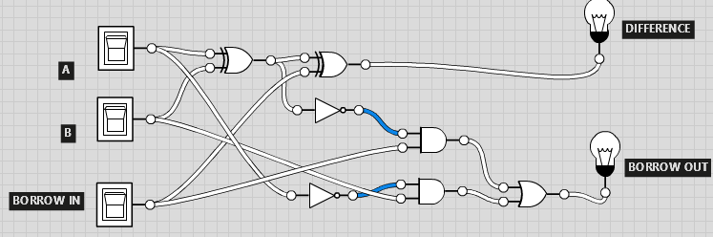

**A=0, B=0, C=1**

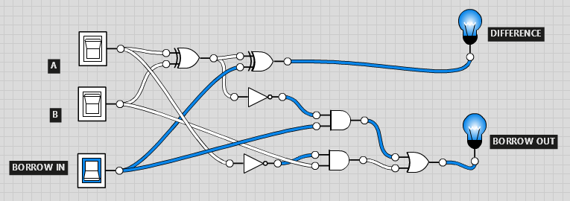

**A=0, B=1, C=0**

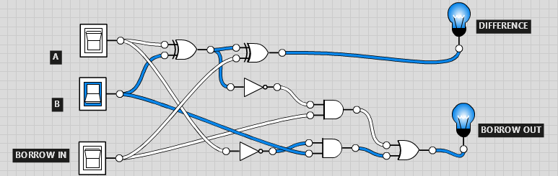

**A=0, B=1, C=1**

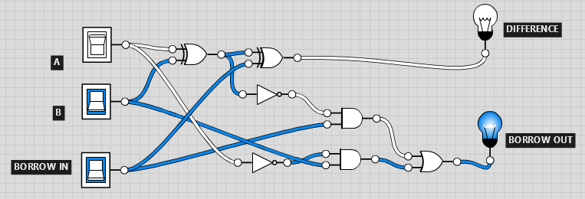

**A=1, B=0, C=0**

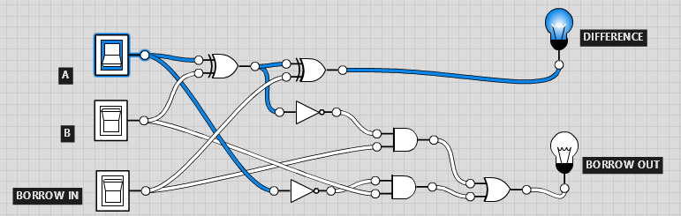

**A=1, B=0, C=1**

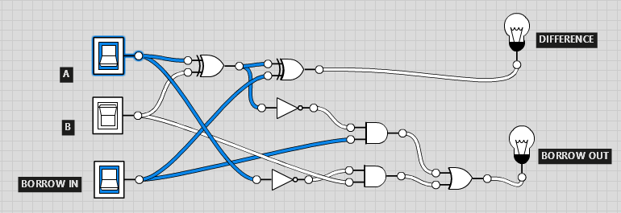

**A=1, B=1, C=0**

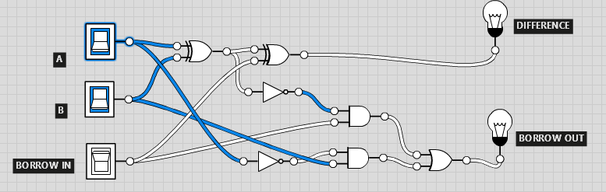

**A=1, B=1, C=1**

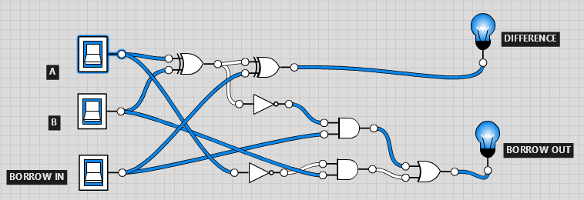

**TRUTH TABLE**

